Dental Radiography Course

Course Objectives:

At the end of this course, students should be competent in dental radiographic technique for use in dental practice in Ireland.

The theoretical component of the course will be lecture based and will be delivered online.
The practical component, basics of radiographic technique will be delivered in Cork University Dental School and Hospital and subsequently supervised by a dentist in practice.

The course consists of 12 modules

The course coordinator is

Dr Caitriona Ahern,
Lecturer in Oral Radiology,
Cork University Dental School and Hospital.

Entry Requirements:

To enroll on the course, you must be a current student of the National Dental Nursing Program of Ireland, on a recognized Dental Nurse training course or a Qualified Dental Nurse or Dental Hygienist.

You will need broadband access to the internet using a computer with webcam and sound (headphones or speakers). You will need a MS teams account.
An email address is required, as all communication is by this method.

You will need access to intraoral, panoramic and Lateral Ceph radiographic equipment and the signed support of a dental practitioner who is willing to supervise you whilst you take radiographs for your logbook.

Qualification: Certificate in Dental Radiography.

Cost: €1150.00

Date: Commencing week of 26th August 2024 to Jan 2025

Duration: 6 months

Course Outline, Application Form and Letter of Support from supervising dentist can be downloaded from www.ucc.ie/en/dentalschool

Closing date for applications: Friday 31st May 2024 at 5pm.

No late applications will be accepted.
Tel: 021 4901175 0r 4545100

E: Caitriona.Ahern@ucc.ie
Completed applications forms (and supporting documentation) will only be accepted in digital format.

Please send to:
Dr Caitriona Ahern, X Ray Department,
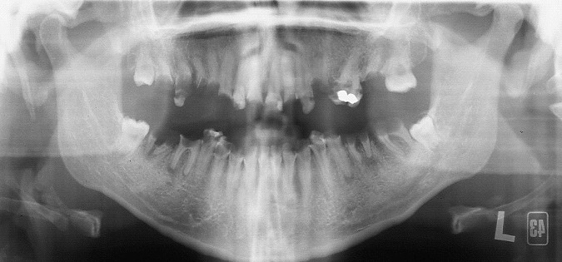
University Dental School & Hospital, Wilton, Cork.

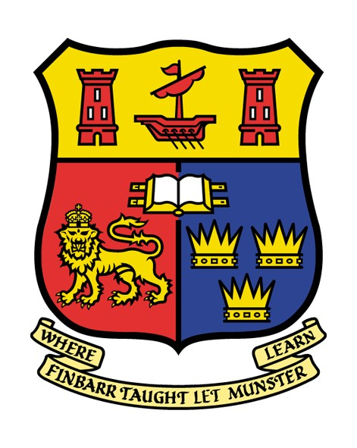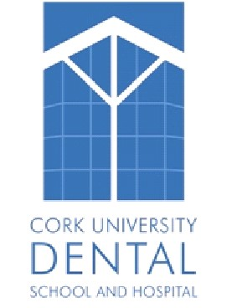

CORK UNIVERSITY DENTAL SCHOOL AND HOSPITAL
UNIVERSITY COLLEGE CORK

Dental Radiography Course for Dental Nurses & Dental Hygienists

The Cork Dental School and Hospital is committed to providing excellent
patient care in a learning environment.
The students and staff will endeavor to adhere to the highest standards of professional care when attending to patients.

